**2 Programming**

In this assignment, we construct several SVM models with different kernels and slack variables to classify the Iris dataset.

The basic form of SVM is given below:

$$\min_{w,b }\frac{1}{2}{\left\|w\right\|}^{2}$$

$$s.t. 1-y_{i}\text{(}w^{T}x_{i}+b)≤0, ∀i$$

Where $w$ is the coefficient of different features, $b$ is the intercept of the hyperplane, $x_{i}$ and $y_{i}$ are the features and labels of the Iris data.

**2.1 (SVM without slack variables)**

1. The optimization problem

We first get the dual problem of the original problem stated above.

The dual Lagrange function is:

$$L\left(w,b,α\right)=\frac{1}{2}{\left\|w\right\|}^{2}+\sum_{i}^{m}{α_{i}(1-y_{i}\text{(}w^{T}x_{i}+b))}$$

The primal and dual optimal solutions should satisfy KKT conditions:

Stationarity:

$$\frac{∂L}{∂w}=0⇒w=\sum_{i}^{m}{α_{i}y_{i}x_{i}}$$

$$\frac{∂L}{∂b}=0⇒\sum_{i}^{m}{α_{i}y_{i}=0}$$

Feasibility:

Complementary slackness:

Then, the dual problem can be derived by substituting all the stationary conditions into the primal problem, finally we get:

Also, is given by:

Since ,

2. Data processing and results

I use OneVsRestClassifier and sklearn.svm.SVC to do the following problems. Since sklearn doesn’t provide strict separation, we use C = 1e5, kernel = ‘linear’ to estimate the attributes and calculate errors. The result is shown below.

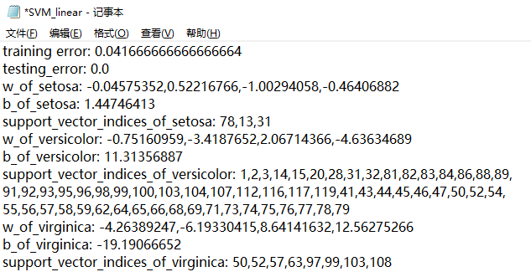

When determining which class is linearly separable, we first calculate the train loss by 1-training score by the sklearn, then if the train loss is 0, it is linearly separable. The statistics are shown below:

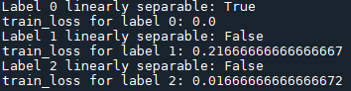

In conclusion, only label 0 (setosa) is linearly separable in the dataset.

**2.2 (SVM with slack variables)**

1. The optimization problem

For SVM with slack variables, we can simply modify it by adding a penalty term.

The dual Lagrange function is:

$$L\left(w,b,α,ξ,μ\right)=\frac{1}{2}{\left\|w\right\|}^{2}+C\sum_{i}^{m}{ξ_{i}}+\sum_{i}^{m}{\left[α_{i}(1-ξ_{i}-y_{i}\text{(}w^{T}x_{i}+b))-μ_{i}ξ_{i}\right]}$$

The primal and dual optimal solutions should satisfy KKT conditions:

Stationarity:

$$\frac{∂L}{∂w}=0⇒w=\sum_{i}^{m}{α_{i}y_{i}x_{i}}$$

$$\frac{∂L}{∂b}=0⇒\sum_{i}^{m}{α_{i}y_{i}=0}$$

$$\frac{∂L}{∂ξ_{i}}=0⇒α_{i}=C-μ_{i},∀i$$

Feasibility:

Complementary slackness:

Then, the dual problem can be derived by substituting all the stationary conditions into the primal problem, finally we get:

$${\text{max}}_{α} \sum_{i}^{m}{α_{i}}-\frac{1}{2}\sum_{i,j}{α_{i}α_{j}y_{i}y_{j}x_{i}^{T}x_{j},}$$

$$s.t. \sum_{i}^{m}{α_{i}y_{i}}=0, { 0≤α}_{i}≤C, ∀i$$

Also, $b$ is given by: $M=\{i|0<α_{i}<C\}$

$$y_{j}\left(w^{T}x_{i}+b\right)=1, ∀j∈M$$

$$⇒ y_{j}\left(\sum_{i}^{m}{α_{i}y_{i}{x_{i}}^{T}}x_{j}+b\right)=1, ∀j∈M$$

Since ${y_{j}}^{2}= 1$,

$$\sum_{i}^{m}{α_{i}y_{i}{x_{i}}^{T}}x_{j}+b= y_{j} , ∀j∈M$$

$$⇒b= \frac{1}{|M|}\sum_{j∈M}{y_{j}- \sum_{i}^{m}{α_{j}y_{i}{x_{i}}^{T}x_{j}}}$$

For the slack variables’ calculation, $max⁡(0, 1-y_{i}\text{(}w^{T}x_{i}+b))$ can return the value of the slack variables, where $y_{i}$ is the label {-1, +1}, $w^{T}x_{i}+b$ is the result calculated by the input vectors $x_{i}$ and the estimated parameters and .

2. Data processing and results

We use a for loop to cyclically write into the output, when deriving the slack variables’ value, we use the decision_function(X) provided by sklearn.svn.SVC to directly get the term $w^{T}x_{i}+b$ and then modify the y_train that it only contains labels of {-1, +1}, finally calculate the value of slack variables.

Below are two sample outputs C = 0.3 and C = 0.7:

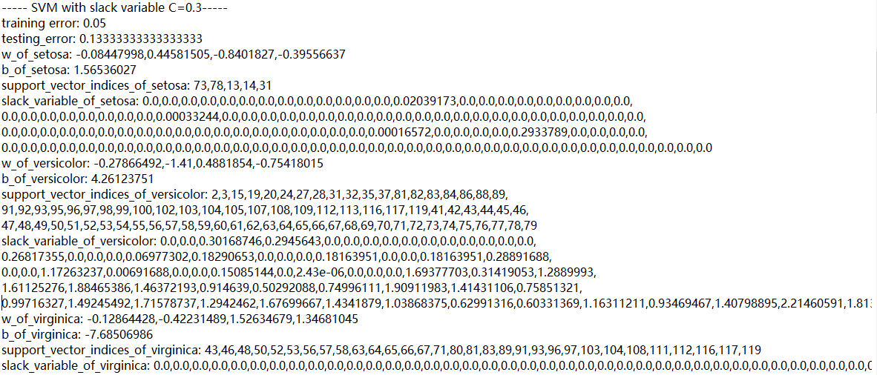

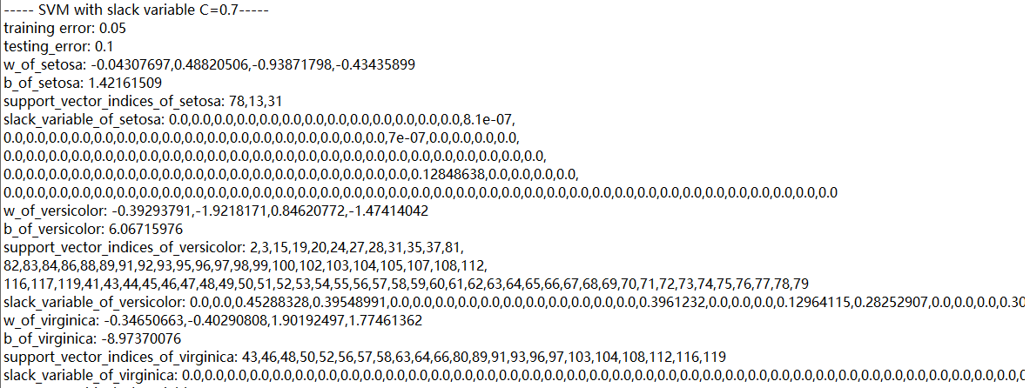

**2.3 (SVM with kernels and slack variables)**

1. The optimization problem

The derivation of the dual problem of the kernel is similar to 2.2:

$${\text{max}}_{α} \sum_{i}^{m}{α_{i}}-\frac{1}{2}\sum_{i,j}{α_{i}α_{j}y_{i}y_{j}k\left(x_{i},x_{j}\right)}$$

$$s.t. \sum_{i}^{m}{α_{i}y_{i}}=0, α_{i}≥0, ∀i$$

The related kernel functions are:

Polynomial kernel:

$$k\left(x,x_{i}\right)={(1+\frac{x^{T}x_{i}}{σ^{2}})}^{p}, p>0$$

Radical Basis Function (RBF) kernel:

$$k\left(x,x_{i}\right)=exp⁡\left\{-\frac{{\left\|x-x_{i}\right\|}^{2}}{2σ^{2}}\right\}$$

Sigmoidal kernel:

2. Data processing and results

(a) In this scenario, we set C = 1, kernel = 'poly', degree = 2, gamma = 1, and get the following output:

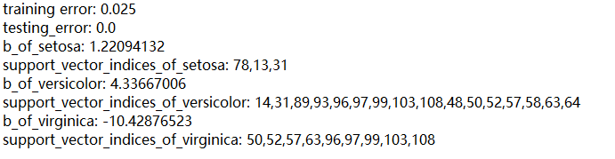

(b) In this scenario, we set C = 1, kernel = 'poly', degree = 3, gamma = 1, and get the following output:

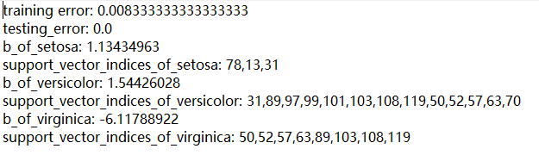

(c) In this scenario, we set C = 1, kernel = 'rbf', gamma = 0.5, and get the following output:

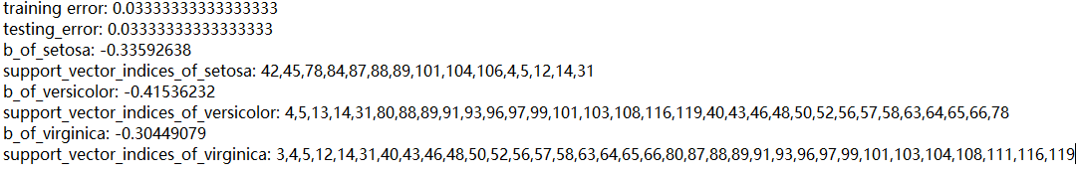

(d) In this scenario, we set C = 1, kernel = 'sigmoid', gamma = ‘auto’ (gamma = 0.25), and get the following output:

